Revitalizing Urban Landscapes: Innovative Scenarios for Amplifying Arboreal Habitat Availability

*Objective*

This study aims to leverage a data-driven design support tool and volumetric modelling to create transformative visions for urban arboreal habitat resources. By integrating and elevating the concerns of both humans and nonhumans we aim to explore how arboreal habitats can be co-produced by trees, birds and humans. Our objective is to encourage innovation through decentralized decision-making processes.

*Significance*

1. Transformative visions serve as essential roadmaps in the transition of cities to become more accommodating to both human and non-human inhabitants.
2. The inherent complexity and diversity of cities require these visions to be a collective product, drawing from a wide spectrum of knowledge, insights, and influences from diverse voices, institutions, and actors.
3. Urban environments offer unique opportunities for integrating wildlife needs into the existing infrastructure. Examples include incorporating habitat structures into building facades, public art, and modifying existing infrastructure like power poles.
4. Arboreal habitats showcase the pressing need for such innovative strategies. Large, old trees provide crucial habitats resources for urban birds but require significant time to develop these. Therefore, ecologists have stressed the necessity for novel strategies, such as artificial habitat structures, to augment the availability of declining arboreal habitats in urban environments.
5. A range of approaches introduces novel ways to better accommodate non-humans and devise new models of collaboration and methods of knowledge-sharing that spark innovation and guide transformations. For instance, emerging wildlife inclusive frameworks integrate habitats into buildings and consider nonhumans as stakeholders in design processes. Others suggest that these approaches are insufficient and call for the restructuring entire political systems, with proposals from global governance to eco-anarchy.
6. In such conditions, experts suggest using visioning and scenario frameworks informed by modelling. They recognise the success in such frameworks in fostering mutual understanding and agreement among diverse groups, and cultivate compelling narratives that can drive change.

*Gap*

1. ***Nonhuman expertise*** While contemporary wildlife-inclusive strategies have broadened design frameworks to incorporate nonhumans into building and infrastructure processes, they remain within the boundaries of current political systems and primarily consider human expertise. This confinement curtails the exploration of a wider range of political tools, such as habitat property rights and alternative economic models, which could enhance the contributions of nonhuman entities like trees and birds in co-creating urban knowledge. Therefore, it limits the potential for innovative, inclusive solutions.
2. ***Common languages in scenarios.*** Likewise, without a common language, the diversity of perspectives can lead to misunderstandings and hinder collective action, making it difficult to achieve by in between diverse groups of urban residents, municipal authorities and others. This makes it difficult to translate individual practices into broader systemic change.
3. ***Modelling****.* Furthermore, the complexity of urban forms and the high costs of urban land use necessitate the support of detailed representation of urban structures. Yet, the complexity of 3D urban environment poses significant challenges for assessment.
4. These gaps represent key areas of knowledge and practice that require further exploration: 1) understanding the potential of nonhuman contributions to urban environments, 2) achieve collective action through a shared language 3) and overcoming the challenges of modelling complex urban spaces.

*Opportunity*

This work represents an innovative fusion of existing and emerging approaches from multiple disciplines:

1. We leverage the expanding recognition of the role of 3D spatial niches for animals (Gámez and Harris 2022), and the understanding of how urban animals utilize vertical space (Mikami et al. 2022). Coupled with the rising interest in 3D green connectivity and amplifying it through the employment of artificial structures such as green walls and roofs (Mayrand and Clergeau 2018), we identify a broader range of opportunities for developing urban habitats.
2. We enhance this approach by integrating voxel-based systems, a tool increasingly adopted across diverse fields including ecology and construction. This integration affords us the capacity to back urban transformation visions with detailed, quantitative evidence.
3. Finally, we incorporate insights from recent research on high-reliability organizations and virtual organizations, focusing on characteristics vital for innovation and persistence, such as reducing dependence on trial-and-error and promoting decentralized information flows (Yu et al. 2020). We also draw from the burgeoning conceptions of cities and communities as collaborative sharing systems, as well as qualitative assessments of rewilding and ecological autonomy. These perspectives underscore the value of decentralized decision-making, knowledge sharing and autonomy across ecological and social systems.
4. Together, these elements enable us allows us to consider a system that amplify voices, both human and nonhuman to explore transformative possibilities for how arboreal habitats can be co-produced by trees, birds and humans, as well as practical steps to get to these futures.

Research Question

1. How can volumetric modelling enhance urban arboreal habitat resources for nonhuman entities such as urban birds, and which scenarios can best use existing infrastructure and various structural types for this purpose?

*Hypothesis*

1. Scenarios developed through volumetric modelling can foster innovation by better integrating the concerns of human and nonhuman stakeholders. This approach allows the expansion beyond the scope of currently implemented actions, while also targeting the most promising and effective interventions.

*Methods*

Our method employs a system designed to bring both human and nonhuman perspectives into focus. This system broadens the scope to explore far-reaching implications and potential transformations for urban arboreal habitat resources, laying down actionable steps to these futures. We use a real-world case to confine the scope of consideration *[MASTER document 3.1].* The goal is not just to imagine these futures, but also to provide a realistic and actionable steps towards them. To do so, we perform the following steps:

1. We look beyond current frameworks by studying interventions and conditions that encourage engagement from all stakeholders, including nonhumans. We use a power-interest grid to assess actions derived from a variety of political tools, design frameworks, and economic structures. These actions expand the possibility space beyond centralized human control, and allow us to reframe sites as communities formed by dynamic networks of more-than-human stakeholder relationships *[MASTER document 3.2].*

* [COMPLETE]. Initial stakeholder power-interest diagram
* [COMPLETE]. Initial clustering of frameworks into those offering nonhumans minimal protections, those viewing nonhumans as partner stakeholders, and those envisioning nonhumans as empowered members of collective systems.
* [TO DO]. Better ground the diagram in the case study. Within it, maybe include the types of stakeholders we could consult for our designs? Ie. your contact at CoM, Darren, Phil .. all the way to birds, trees…
* [TO DO]. Would appreciate some help developing some key outputs of this step. I guess – some form of assessment space we use in the last step? Some form of validity in the sense that this expanded scope has people seriously considering it and that the political stuff can be considered in the same space as currently operationalised processes?
* [TO DO:] It would be good if it also expressed concrete implications for what we mean by nonhuman expertise and integrating this expertise in our modelling. How can this inform this resource-packet approach?

1. We refine our focus by systematically scanning the city to pinpoint promising intervention sites. This larger scale spatial analysis highlights distinctive sites, difficulties, and prospective intervention opportunities *[MASTER document 3.3.1].* From these categories, we choose representative sites for detailed study *[MASTER document 3.3.2].*

* [HALF COMPLETE] Target species: urban woodland birds (ie. New Holland honeyeater (Phylidonyris novaehollandiae)) that use resources practically able to be provided by artificial structurers. Do we include others?
* [COMPLETE] Break down urban space into four components and plot these: Features boosting arboreal habitat resources, Features boosting green connections, Features boosting arboreal habitat resources, Features depleting green connections. [We can also include more spatial patterns at this scale too if needed, but I thought perhaps not necessary as it isn’t the focus of our strengths, and we can save some more of the analysis to the volumetric modelling].
* [COMPLETE] From this, identify a simple typology consisting of three site conditions: Inner-City Streets with Remnant Trees, Urban Parks Undergoing Change, Inner-City Barren Sites.
* [POTENTIAL EXTENSIONS] I’ve removed the Canberra sites, I don’t have the same datasets and the considered sites don’t really fit with this analysis.
* [COMPLETE]. Selection of 3 representative sites. I think I cover a good breadth of levels of intervention, different urban dynamics, etc. I think 100x100m is a good size as the z direction isn’t lost. We could expand this 250x250m sites if we wanted to.
* [POTENTIAL EXTENSION] I could make this assessment more quantitative, but again, I thought not really the focus of this. Currently just grouping the results into three clusters by visually inspecting the maps (see result 4.2).

1. We assess these sites for design opportunities that can strengthen community relationships and enrich urban arboreal habitat resources. To do so, we use a combination of terrestrial and aerial lidar data as well as feature recognition techniques to volumetrically represent sites. We evaluate these volumetric representations using octrees, hierarchical data structures suited for modelling complex 3D spaces.
   1. We first partition each sites as nodes. We initially extract 'material nodes’ that capture existing features such as ground, buildings, trees, street furniture, and other elements. We identify potential sites for design interventions, such as walls and roofs that can accommodate artificial structures. We also create 'non-material nodes' that represent various community relationships, threats, and opportunities. These nodes capture intangible but impactful elements such as human dominance, persistence of resources, redundancy of resources, level of human intervention, resource supply cycles, and other relationships *[MASTER document 3.4.1], [Supplementary Materials Appendix 4: Node descriptions]*

* [COMPLETED]. Generated a 1m or 0.5m voxel grid from the aerial lidar site data.
* [POTENTIAL EXTENSION]. The quality of the Melbourne scans is OK but could be improved. I have the option to incorporate some terrestrial scanning, but this might not be needed given our scope? As an alternative, I could focus on modelling some of the buildings in more detail in Rhino.
* [COMPLETED]. Octree engine, within initial parsing of assessment of environment’s capacity to host artificial structures.
* [TO DO]. I thought best to get it running and then we can both have a bit of brain storm for how best to use it, and to understand what the resource-packet approach implies for implementation. This engine will play a significant role in our broader political assessment and engagement with nonhumans, as it allows nodes to interact and amalgamate attributes. More details on my current implementation are provided below.
* [COMPLETED]. Initiated recognition of 'material' nodes, a semi-manual, semi-automatic process. Currently, it can recognize and tag buildings, trees (small, medium, large), roads, grass, and urban furniture.
* [TO DO]. For 'non-material' nodes, refer to the cross-referenced method table and the attribute types table in the supplementary materials. Assessment options include proximity to green connections, zoning (residential, commercial, protected green space, incidental space), surface roughness, human dominance, resource persistence, redundancy of resources, the level of human intervention, resource supply cycles, and decision centralization.
* [TO DO]. Need to determine how to incorporate conditions such as available funding, time constraints, and the acceptance level of urban dwellers towards unconventional structures into these non-material nodes.
* [TO DO]. Assessment of opportunities for artificial habitat structures in urban spaces. Currently recognizing horizontal and load-bearing roofs suitable for green roofs. The goal is to make the material and non-material nodes generate other 'habitat ready' voxels.

* [NEARLY COMPLETED]. Substituted low-quality tree clusters in the aerial lidar with equivalent tree blocks from my own scans/aggregation with Darren's data. Ie, I’ll swap out a street – large, park – medium tree with my own version. These conditions define the resources in trees, their persistance, etc.
  1. To consider possible interactions at our sites, we also aggregate nodes into blocks that represent distinct environmental objects or areas that have the potential to serve as arboreal resource providers. We describe these blocks as resource providers and numerically outline their constraints. ‘Historical provider’ blocks encapsulate attributes of trees under different ages and management conditions [MASTER document 3.2]. ‘Novel provider’ blocks consider attributes of proposed artificial structures. These blocks offer a spectrum of numerically defined current and future possibilities influenced by varying degrees of human control and design *[MASTER document 3.4.2], [Supplementary Materials Appendix 4: Block descriptions]*
* [ALMOST COMPLETE]: Tree blocks: three different trees (young, middle-aged, old), across three levels of control (highly managed, moderately managed, unmanaged). Have a look at the cross-referenced MASTER and Supplementary Material docs for numeric description of resources types I will measure.
* [COMPLETE]. Initial selection of artificial structure blocks as well as some of their numeric constraints, done by reviewing the green literature.
* [TO DO]. Turn this table into voxel design templates
* [OPTIONAL]: expand the potential design types. We could add something to the methods about consulting some experts? Ie. Phil, Darren, your council contact. That’s what these guys did: Croeser et al., “Finding Space for Nature in Cities.”, ie:
  + “We consulted a green infrastructure specialist in a state road agency, as well as specialists in water sensitive urban design, urban ecology, and urban forestry (all of whom are co-authors of this paper) to identify constraints and opportunities (Table 3).”

1. We then create a set of future visions.
   1. To understand the benefits of the future visions, we compare them across a range of scenarios. These scenarios use our building blocks to reconstruct sites along a spectrum of human control. We construct representations of sites both as 'Nonhuman-designed' with minimal human intervention (baseline conditions) and 'Human-designed' with high levels of human control (current and predicted future conditions) *[MASTER document 3.5.1].*

* [COMPLETE]: three sites
* three initial reconstructions for each: 1) evolved relationships, 2) current state, 3) expected future relationships (demonstrating high control).
  1. We then consider visions for hybrid futures. These scenarios blend centralized human control with other relationships. To formulate these visions, we establish targets and draft a series of corresponding briefs that propose strategic interventions capable of transforming current urban spaces to align with these targets. Using these briefs and the modelled constraints from the previous steps, we create a series of evidence-backed visions that align with these targets. *[MASTER document 3.5.2].*
* [TO DO]. Establish targets – I was thinking along the lines of some simple ones like 50% of surfaces permeable, all habitat resources there, redundancy and minimising of shocks, persistence, supply cycles.
* [COMPLETE]. Initial design briefs, 1 future vision for each site. They are in the *[MASTER document 3.5.2].*
* [TO DO]: construct representations in response to the brief. OPTIONS – automatic allocation across the site or manual – but still based on assessment of ‘habitat ready’ voxels as above.

1. Finally, we assess our future visions, demonstrating the progress made by integrating nonhuman perspectives compared to current leading approaches *[MASTER document 3.6].*

* [TO DO]. Consider the structure of this comparison. Is it OK just to compare the briefs with the past, current and predict outcomes? Maybe that + plotting the sites on the power-interest grid again?

*Results*

*SR: See each cross-referenced section in the MASTER doc for images.*

1. We identified three distinct framework clusters: those offering nonhumans minimal protections, those viewing nonhumans as partner stakeholders, and those envisioning nonhumans as empowered members of collective systems.
2. Our spatial analysis showed the prevalence of three urban arboreal habitat conditions: Inner-City Streets with Remnant Trees, Urban Parks Undergoing Change, and Inner-City Barren Sites *[MASTER document 4.2].*
3. Employing an octree data structure, we divided space according to demand, generating multi-scale blocks with varied attributes. This hierarchical approach allows us to numerically calculate influential attributes for non-human inhabitants [MASTER document 4.4.1]. We successfully constructed volumetric representations of these typical sites [MASTER document 4.3.1], and characterise the capacity of environments to host additional structures. We integrate trees and artificial structures into quantitatively defined habitat provider blocks [MASTER document 4.3.2]. To connect with our proposition of acknowledging all contributors as designers – human, nonhuman, hybrid, and more – the distinctive feature of this approach rests in our characterization through numerical constraints.
4. Our numeric comparison exhibits varying site conditions across levels of human control. *[MASTER document 4.4.2].* We also we constructed future visions for our sample urban sites *[MASTER document 4.5].* These visions serve as a tangible depiction of what these 'hybrid futures' could potentially look like.
5. Finally, our comparison demonstrated the value of including nonhuman voices in urban planning and design *[MASTER document 4.6]*.

*Discussion*

1. Our research demonstrates that the necessary urban transformation cannot be accomplished without political intervention and the active engagement of empowered non-human entities. Their participation is pivotal to broaden the search landscape, entertain previously unconsidered solutions, and ensure a consistent approach to urban change.
2. Concurrently, the expanded scope revealed by volumetric analysis unveils numerous overlooked opportunities for urban rejuvenation. This analysis allows us to pinpoint and examine these prospects, narrowing the search area and facilitating a swifter, smoother, and less precarious path towards urban revitalization.
3. Platforms like the artificial tree toolkit support this interspecies collaboration, serving as decision support tools that bridge the gap between extensive political aspirations and practical steps towards more inclusive cities. They do not just imagine these futures, but also demonstrate the feasible and actionable steps towards them.

*Contribution to Knowledge*

1. Our research highlights the proactive role non-humans can play in shaping future urban landscapes. We demonstrate the capacity of expanded technical systems and quantitative assessments in this collaboration. These systems function as a common language among municipal authorities and urban residents, promoting tangible real-world experiments, the iterative development of structures, and enabling the creation of elements with which non-humans can actively engage.

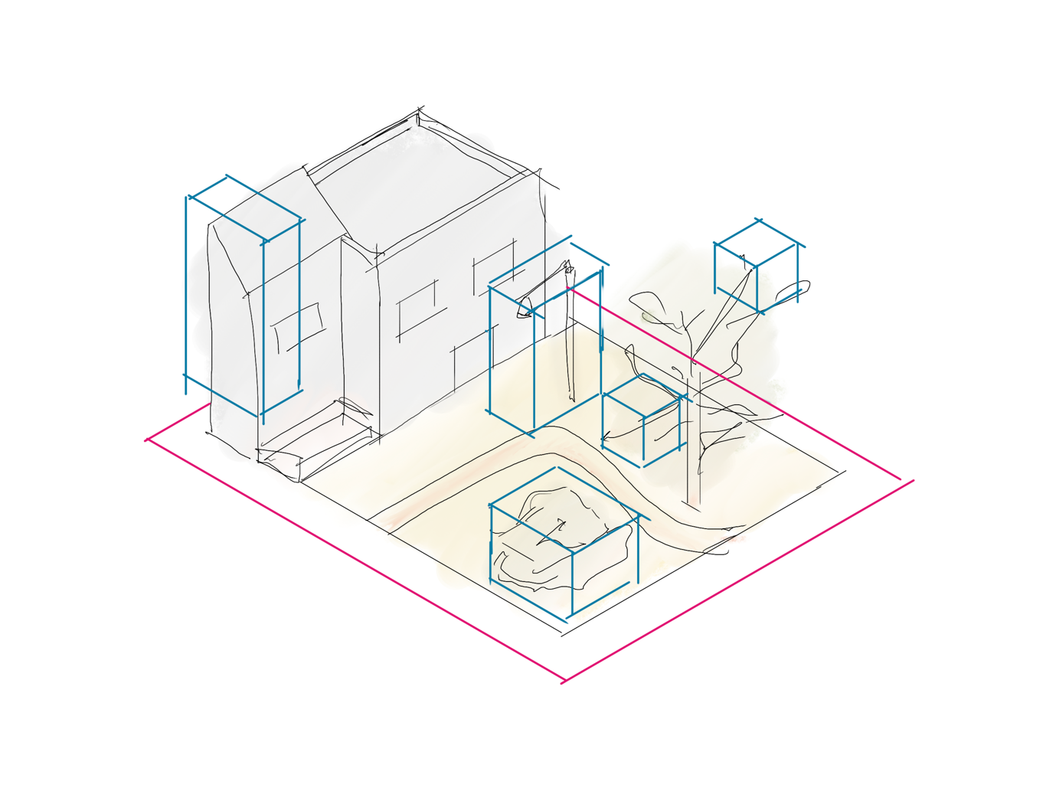

Figure 1. Sketching out the design tool - the scale we consider. Energy and material flows from higher organisational levels (pink) [ie. zoning, connectivity, etc], as well as the smaller organisational levels (blue boxes - habitat affordances of walls, exposed branches in an old tree across a path, etc].

# Bibliography